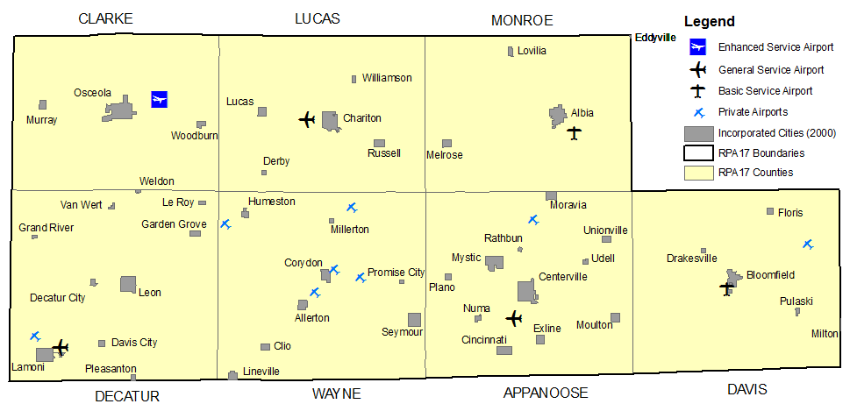
Chariton Valley Transportation Planning Affiliation – (RPA -17)
Administered by: Chariton Valley Planning & Development Council
308 North 12th Street, Centerville, Iowa 52544
641-437-4359
www.charitonvalleyplanning.com

